Hello, I created this short roleplay to accompany my tableau dashboard and help give context to my project for selecting a new store location for DVD rentals, since business context is ultimately what drives analysis, it helped to guide my code experience, and was fun to put together.

EMAIL FROM MANAGER TO JEFFREY

Jeffrey

The board is thinking about expanding our movie chain to another location, we mostly mail out movies nowadays, so getting postage down by being in the same country as the largest amount of sales is the priority. Could you put together a dashboard from the database on some of that?

Thanks

Mr. Joe Manager

CODE:

SELECT country, city, amount AS rental_price, payment_date, title, replacement_cost, l.name AS language

FROM country AS co

JOIN city ON

co.country_id = city.country_id

JOIN address AS a ON

city.city_id = a.city_id

JOIN customer AS cu ON

cu.address_id = a.address_id

JOIN payment AS p ON

cu.customer_id = p.customer_id

JOIN rental AS r ON

p.rental_id = r.rental_id

JOIN inventory AS i ON

r.inventory_id = i.inventory_id

JOIN film AS f ON

i.film_id = f.film_id

JOIN language AS l ON

f.language_id = l.language_id

WHERE l.name NOT LIKE 'E%'

;

Exported as csv from pgAdmin and imported to Tableau Public

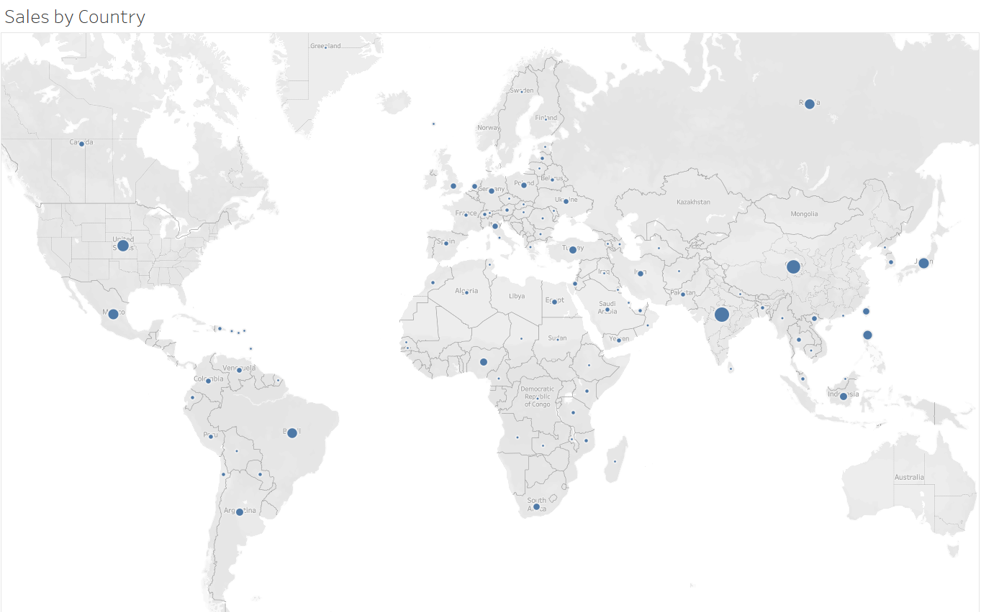

TO MANAGER FROM JEFFREY:

Mr. Manager

I’ve attached the sheet in this email. It looks like India is the country with the largest amount of sales, you can also see China nearby has second most. Since all the movies are in English with subtitles language shouldn’t be a concern. We’re also doing really well in southeast asia, it might be beneficial to put the store in China if it will lower costs around SE Asia.

Jeff

TO JEFFREY FROM MANAGER:

Jeff

That looks great, they’re thinking we should try and use the 150 highest earning movies for that region, could you provide a list of them along with the total price we have stored?

Thanks again

Mr. Joe Manager

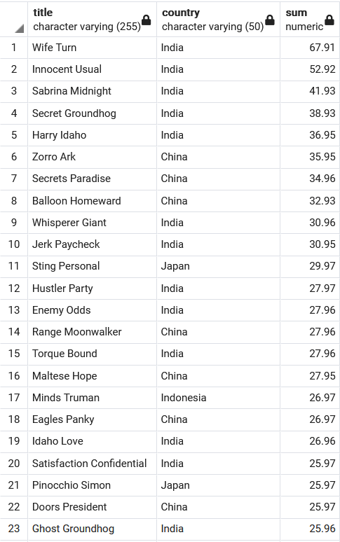

CODE USED:  
SELECT f.title, country, SUM(AMOUNT)

FROM country AS co

JOIN city ON

co.country_id = city.country_id

JOIN address AS a ON

city.city_id = a.city_id

JOIN customer AS cu ON

cu.address_id = a.address_id

JOIN payment AS p ON

cu.customer_id = p.customer_id

JOIN rental AS r ON

p.rental_id = r.rental_id

JOIN inventory AS i ON

r.inventory_id = i.inventory_id

JOIN film AS f ON

i.film_id = f.film_id

JOIN language AS l ON

f.language_id = l.language_id

WHERE country IN ('China','Japan','Russia','Indonesia',

'Phillipines','Taiwan','India')

GROUP BY f.title, country

ORDER BY SUM(amount) DESC

LIMIT 150

;

Returns list of movies

Sample shown right

When run as subquery or subview with Sum returns total cost of $3088.50



TO MANAGER FROM JEFF:

Here is the attached document with the list of movies. Also the total cost for buying these top 150 movies to stock the new store would be $3088.50.

Jeff

TO JEFF FROM MANAGER

Thanks I’ll take this information to the next meeting and discuss.

Manager